Based on the transcript, here is a FAANG/HLD interview-focused note.
Proxy, Reverse Proxy, Nginx & Load Balancer Notes

1. What is a Proxy?
A proxy is a middleman between two parties.
Client <--> Proxy <--> Server
There are two types:
1. Forward Proxy
2. Reverse Proxy

2. Forward Proxy
A Forward Proxy represents the client.
Employee
|
Forward Proxy
|
Internet
Example:
Company Network
|
Corporate Proxy
|
Google, YouTube, etc.
Uses
✅ Hide client IP
✅ Block unwanted websites
✅ Virus/Malware filtering
✅ User activity logging
✅ Caching

Example
Without Proxy
Employee ---> Internet
With Proxy
Employee ---> Proxy ---> Internet
Website sees:
Proxy IP
not employee IP.

Interview Definition
A Forward Proxy sits in front of clients and forwards requests to external servers while providing security, filtering, logging, and caching.

3. Reverse Proxy
A Reverse Proxy represents the server.
Client
|
Reverse Proxy
|
Backend Servers
Client never directly reaches backend servers.

Example
User
|
Nginx
|
Spring Boot
or
User
|
Nginx
|
Service A
Service B
Service C

Responsibilities
✅ Hide backend servers
✅ SSL Termination
✅ Routing
✅ Caching
✅ Logging
✅ Security
✅ Load Balancing

Interview Definition
A Reverse Proxy sits in front of backend servers, receives client requests, applies security and routing rules, and forwards requests to appropriate backend services.

4. Reverse Proxy vs Forward Proxy
Feature | Forward Proxy | Reverse Proxy
Represents | Client | Server
Hides | Client | Backend Servers
Used By | Employees/Browsers | Applications
Example | Corporate Proxy | Nginx, ALB

5. What is Load Balancing?
Load balancing means:
Distribute requests across servers
Example:
Request1 -> Server1
Request2 -> Server2
Request3 -> Server3
Purpose:
✅ Prevent overload
✅ High availability
✅ Better scalability

6. Nginx
Nginx is:
Web Server
+
Reverse Proxy
+
Load Balancer
Can perform:
SSL Termination
Routing
Caching
Load Balancing
Rate Limiting
Static Content Serving

Nginx Example
User
|
443
|
Nginx
|
8080
|
Spring Boot
Nginx receives:
GET /users
Forwards:
localhost:8080

7. What is ALB?
ALB = AWS Application Load Balancer
It is a managed:
Layer 7 Load Balancer
+
Reverse Proxy

Request Flow
Browser
|
HTTPS 443
|
ALB
|
10.0.1.10:8080
ALB:
- Terminates TLS
- Reads URL/Header
- Selects target
- Creates new connection
- Sends request to EC2

ALB is also a Reverse Proxy
Browser
|
ALB
|
Spring Boot
Client never talks directly to Spring Boot.

8. Nginx vs ALB
Feature | Nginx | ALB
Reverse Proxy | Yes | Yes
Load Balancer | Yes | Yes
SSL Termination | Yes | Yes
Managed by AWS | No | Yes
Auto Scaling | No | Yes
Path Routing | Yes | Yes
Caching | Yes | No
Rate Limiting | Yes | Limited

9. Why Use Both ALB and Nginx?
Real production:
Internet
|
ALB
|
Nginx
|
Spring Boot Services
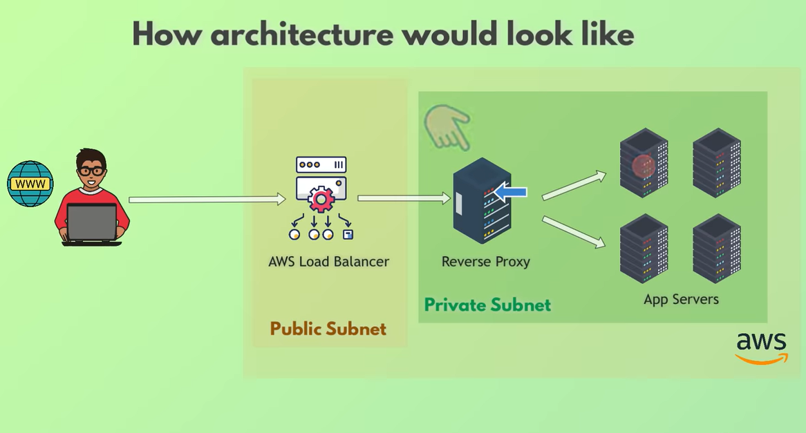

ALB Handles
External Traffic
SSL
Health Checks
Basic Routing

Nginx Handles
Internal Routing
Caching
Compression
Rate Limiting
Advanced Rules

10. Microservices Architecture
User
|
ALB
|
Nginx / Ingress
|
-------------------
| User Service |
| Order Service |
| Payment Service |
-------------------
Routing Example:
/users/* -> User Service

/orders/* -> Order Service

/payments/* -> Payment Service

Kubernetes Mapping
Internet
|
Cloud Load Balancer
|
Ingress Controller
(Nginx)
|
Pods
Where:
Cloud Load Balancer = External Entry Point

Ingress Controller = Internal Reverse Proxy

Most Important Interview Answers
What is Forward Proxy?
Forward Proxy sits in front of clients and forwards requests on behalf of clients.

What is Reverse Proxy?
Reverse Proxy sits in front of backend servers and forwards requests to appropriate servers.

Is Nginx a Load Balancer?
Yes. Nginx can act as a reverse proxy, load balancer, web server, and SSL terminator.

Is ALB a Reverse Proxy?
Yes. ALB is a Layer 7 reverse proxy that terminates HTTPS connections and forwards requests to backend targets.

Why use ALB and Nginx together?
ALB handles external traffic, SSL termination, health checks, and AWS integration, while Nginx provides advanced routing, caching, compression, and fine-grained traffic control inside the application network.

One-Line Memory Trick
Forward Proxy -> Protects Clients

Reverse Proxy -> Protects Servers

Nginx -> Self-managed Reverse Proxy

ALB -> AWS Managed Reverse Proxy + Load Balancer

